Software engineering
A report on the ways in which software engineering can be measured and assessed.
Matthew Flynn
17327199
Abstract
Considering the ways in which software engineering can be measured and assessed in terms of the following: Measurable data, the computational platforms to perform this work, the algorithmic approaches available and the ethical concerns surrounding this kind of analytics.

Table of Contents

1. Introduction Defining Productivity, Regarding Software Engineering: 2
2. Measurable Data: 3
2.1 Lines of Code 3
2.2 Time 3
2.3 WIP Limits 3
2.4 Reusability of code: 4
2.5 Function Point Analysis: 5
3. Computational Platforms to perform this work: 6
3.1 Repository Hosting services 6
3.2 Personal Software Process (PSP): 6
3.3 Hackystat: 7
4. Algorithmic Approaches: 8
4.1 Code Churn: 8
4.2 The gamification of the software process: 9
5. Ethics: 9
5.1 Misunderstanding what the purpose of Productivity metrics is: 10
5.2 Data, Privacy and Misuse: 11
5.3 Personal thoughts of Ethic issues 12
6. Conclusion: 13
7. Sources: 14

Introduction Defining Productivity, Regarding Software Engineering:
Productivity can be defined as the rate of output per unit of time i.e. output/input. This seems very simple and straightforward, and it is for most occupations. However, with regards to software engineering there is a lot of interpretation about what is the input and output and whether something is productive or not can depend on what we choose as our input and output.
For example, if two people can write a program to compute whether a set of three integers are valid lengths for the sides of a right-angle triangle. If one is created with twice as many lines of code as the other, you could reasonably say that the one with less code is more efficient, making the author of the shorter program the more productive coder. However, this is obviously incorrect as the person with twice as much code could have simply used a different coding standard which requires more new lines, they could have accounted for more error cases or they could have just desired to make the code more readable for his team. In all cases, you could say the longer code is more productive. The above example uses the lines of code as input and the functionality as output. However, for a more extreme example if the lines of code are the output and the time is input a person could continuously write “a” [enter] and they would be extremely productive.
Given the examples discussed above, the simple answer would be to employ someone to observe the productivity of the code writing staff. However, when the company cannot meet deadlines the production observer could simply say. “They were here at the office for 12hrs at their computers writing code of length X.” This would not improve productivity, only providing context for the missed deadline. You do not know who is writing the best code, is the team simply not up for the task, is there a problem with discoordination, coding standard, inefficiency with unit testing etc. This is why it is so important to define what productivity is in regard to software engineering. Unfortunately, nobody has a definitive answer, but by using some measurements to help, companies try to find the gaps in their productivity. This involves measuring productivity from many pools of data in order to determine where these gaps and inconsistencies can be resolved through quantifying the process.
For the purpose of this report, productivity will be determined by the amount of code written and the quality of that code. The amount of code written is the flat lines of code written, whereas the quality of the code is more complex and involves the reusability of code, its performance, readability etc.

2. Measurable Data:

2.1 Lines of Code
The first measurement of productivity to examine is the lines of code (LOC). LOC can be a good measurement when measuring productivity for low level languages. Due to a lack of tools available, it can be argued that a higher LOC count reflects more detail and steps taken to resolve or prevent issues in the program. Additionally, LOC can be used as a measurement of complexity for low level languages since most complex systems require significantly more lines of code than high-level languages. When software engineering was in its infancy in the 1960s, LOC was the main method used as most people were using very low-level languages. Despite the wide recognition of its short comings from academics, LOC is still used in some capacity in the industry even to this day. It is a very simple and measurable piece of data and can give a very broad overview to demonstrate to client’s what work is being done. The majority of companies are not interested in extraneous data and LOC is an easy to understand, measure and compare concept, but does have some shortcomings in understanding and distinguishing between overall quality of work. Through the development of more high-level languages and complex systems, LOC is still used in conjunction with much more data to reach its conclusions, as opposed to a straight count.

2.2 Time
Similar to LOC, time taken to complete a task is another measurement of software productivity which has inherent flaws when it is used as the sole measurement. For instance, time to complete tasks is very important in both the agile and waterfall development strategies since both set out goals that need to be completed in a set amount of time. It is especially problematic in waterfall development since any piece of a project stalling causes delays to the whole system. In agile development the effect is far less severe as the process is constantly adapting and the problems may be discussed and dealt with in the next scrum and/or by the scrum master. In both cases, time is easy to measure, read and comprehend and is therefore often factored into when examining productivity. However, when time is used in conjunction with other methods of monitoring productivity, it can be used more effectively.

2.3 WIP Limits
In agile development work in progress (WIP) limits are used to identify inefficiencies in a team’s workflow. WIP limits set a maximum amount of work that can exist in each status of a workflow. WIP limits help identify bottlenecks and blockages as they appear and gives a very clear and up to date view of the process as it is being produced. In WIP, the emphasis is placed on what is done and what must be done. There is much more incentive to get the goals complete. It is therefore an extremely effective way of measuring productivity as it makes issues evident as they appear, and they can be noticed and dealt with quickly by the team and scrum master. These can also be identified after the project is complete. The data is not as readable and requires a bit more technical knowledge to utilise to its full extent. Despite this, it is a very powerful and accurate measurement of the progress of the project and can be used to infer productivity very easily.

2.4 Reusability of code:
One of the cardinal rules of software is software is only good when it can be applied to many things. Therefore, reusability of code is a core piece of good code, meaning it can be used as a metric for good code and productivity through its’ ability to be reapplied in later projects. Determining whether software is usable or not is a complex task, but it can be measured using different metrics. Commercial tools can generate static metrics automatically. More observable metrics include, adherence to formatting standards and style guidelines, completeness of tests, integrated instructions, documentation etc. In this paper we will be focusing on the empirical data involved in determining code reusability.
You can map reusability to portability. The US Department of Defence in a 1990 report concludes that the measure of code portability comes from the number of source lines that need to be removed/changed to allow execution in a different environment. However, while this general statement does not account for all possible applications, it is a good place to start. Complexity is also a factor in how reusable a piece of code is as often complex code is more specific and thus harder to comprehend. Developers that wish to use the code may find it difficult if the code is not well documented and commented, and harder to migrate since complex systems have very specific requirements. Object orientation is a good way to solve this and it is often the best mindset to take when wishing to reduce complexity of different code segments. Object orientation provides reusable code, as does functional programming, since they help break down problems into smaller simpler modules that can be reused in many programs.
While reusability is a great metric for measuring the quality of code, it is a very roundabout way of doing it and while you will see improvements over time it is very hard to measure and there is no obvious intrinsic benefit that can be used. Time constraints and other factors of productivity can often cause reusability to be under-utilized. Essentially, it is an investment at the start of a project in order to reduce future efforts. Therefore, although it is a great measurement of code quality and can be used to infer productivity, it is hard to implement.

2.5 Function Point Analysis:
Function Point Analysis (FPA) is a method of measuring functional size by assessing the functionality delivered to its users using the users external view of the functional requirements. There is a heavy focus on the logical view of the application rather than the technical implementation. The activity of FPA is often called Function Point Count. Once the result has been gathered you can use it on its own or combine it with other measures to develop the following indicators: scope of product, quality indicators, performance and productivity. The way the result is calculated is using the table of function point complexity which contains the average complexity of different components of a program, the typical characteristic weights and using the formula FP = UFP * VAF where UFP is the sum of all complexities, VAF is the value added factor i.e. 0.65*(0.01 * TDI). TDI is the total degree of Influence of the 14 general System Characteristics. By preforming this calculation, you get the exact function point count which can be used to help create a metric for productivity. Function point analysis is widely used as one of the metrics when software productivity and progress reports need to be displayed.
Figure1: Simplified model of productivity [4]:
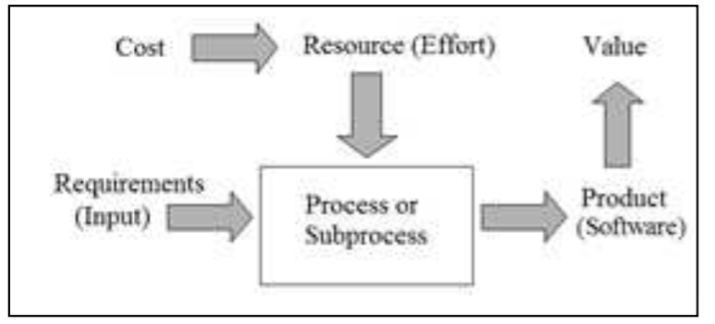

3. Computational Platforms to perform this work:
Like with any service, there are many different platforms and programs that can be used when completing a software engineering project to assist in measuring the productivity of its staff and in improving productivity.

3.1 Repository Hosting services
Repository Hosting Services are the single most important supporting component of any software project. Repository Hosting Services allow you to store different versions of the software project, different team members can commit changes to the project either directly to the master or to a branch which can be merged at a later point and code can be pulled from the public directory. This massively increases productivity as changes to the master branch can be set so they must be approved, and you can see which member of your team has been uploading pieces of code and what they have contributed to the overall project.
The platforms also help greatly with the reusability of code and can be an easy way of retrieving the LOC each individual contributor has committed. Github is currently the most popular repository hosting platform however other significant platforms include bitbucket, sourceforge, gitlab and launchpad. Most of these platforms provide a restful API service for querying and can be used to compare your teams progress against other projects using whichever metric you set. They all also contain highlighting lines that have been added and removed at each commit, provide graphing services for visualization of such data as, the lines of code each developer has committed, when a commit occurred, where exactly the code was edited, by whom and how frequently each developer commits to the repository. These are all useful metrics for gathering data that can be used to measure productivity and can all be gathered and visualized automatically and accurately.

3.2 Personal Software Process (PSP):
PSP is a software development process, developed by Watts S. Humphrey, which allows developers to improve performance and track their predicted and actual development of produced code. It involves measuring Size of the project (or a proxy size), time/effort and defects (including time wasted). There is a strong emphasis on static verification. It involves moving up from PSP0 to PSP3 and is an evolving process.

Figure 2: Breakdown of PSP evolution [6];
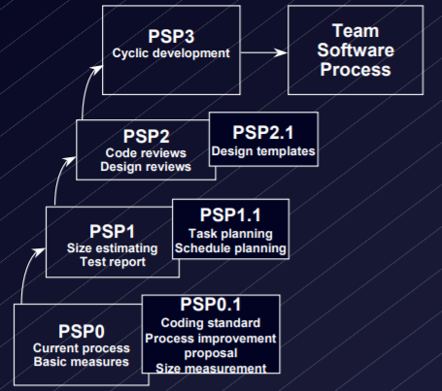
In PSP0 engineers use their current methods so data may be analysed and reported on. This is to gather baseline data. The PSP1 augments the PSP0 to include coding standards, size, resource and schedule estimating, a Process Improvement Proposal (PIP) and a test report including earned value tracking. This is to allow engineers to use historic data to improve estimates and project the likely statistical ranges of their estimates in order to learn how to reduce it. PSP2 augments PSP1 to include personal design, cost/yield/quality measures, completion criteria and design templates. PSP3 is just a step up from that and allows developers to see PSP being applied to a large-scale including cycle development and issue tracking logs. PSP2 allows developers to use historic data to improve quality by measuring efficiency of defect removal and various quality measures (yield, cost of quality and appraisal/failure ratio). PSP3 allows developers to see how the method can be adapted for different types of work.
PSP is a fantastic method for measuring productivity and is very quick to spot and address where areas can be improved. It is a bottom up system for improving overall productivity starting at an individual level and moving up to the team level.

3.3 Hackystat:
Hackystat is an open source framework that allows collection, analysis, visualization, interpretation, annotation and dissemination of project development and project data. Hackystat is not a conventional monolithic system, it is a collection of smaller tools that extend past the base toolkit. They include Twitter, Google Charts, Tickertape, ProjectBrowser, Telemetry, Sensor Base and Sensor. Hackystat is, essentially, a data gathering and abstraction framework which can be accessed easily by all developers on the team and used to identify the source of problems as they appear in the project.

Figure 3: Hackstat functionality [8]
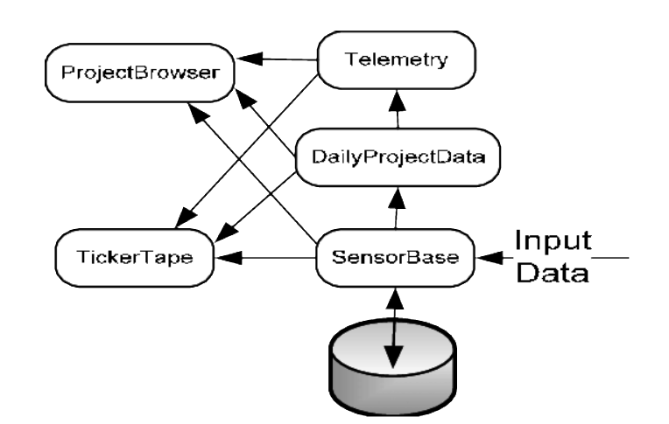
Hackystat first has to be given access to the developer’s IDE/text editor where it gathers data as work is done and sends the gathered data automatically to the SensorBase. The Sensor component gathers this data. From there you can use several different systems to abstract and display the data. The raw data can be sent to the ProjectBrowser however since raw data is almost unreadable most of the time you can use the DailyProjectData to abstract the raw data before its displayed, or you could send it through the telemetry after the DailyProjectData which then identifies the trends and using Google Charts helps display the data. You can also use TickerTape to get information about a variety of lower level Hackystat services and using Twitter, it tweets the information to all people connected to the project via Twitter.

4. Algorithmic Approaches:
Algorithmic approaches to improving productivity of software development can be used in to separate ways. The first is an algorithmic approach to gathering the data similar to the Source functionality of Hackstat (Section 3). The second is an algorithmic approach which fundamentally changes the engineering process so that efficiency can be measured.

4.1 Code Churn:
Code churn is a metric by which the change in volume is measured between two versions of a system. It is defined as the sum of added, modified and deleted lines. Code churn is easily retrieved from the repositories mentioned in section 3. This algorithmic approach is very simple and is a far more practical and visual measure of LOC. Additionally, it is a good extra piece of data to have which roughly indicates the amount of work done by a specific developer for a specific commit. Similarly to LOC, this process is not useful for multiple projects as each project will have its own distinct pattern. However, this can be used to approximate the amount of work done, but not the progress of the project necessarily.
In spite of this, there are some interesting observations we can infer from the code churn. Firstly, code churn is roughly how much a project has changed. The more a project changes the more developers could become confused by what is happening and especially when the project is an open source. Large amounts of code churn normally indicates there will be a lot of problems with reusability and that the files that are being edited regularly have contained a lot of bugs and might contain more.

4.2 The gamification of the software process:
Gamification is the application of typical elements of games to jobs/tasks. Sometimes this is used in order to get clients to engage with an advertisement, product or a service. This is often used in online marketing when directed at clients. However, with regards to software we can use gamification to potentially increase productivity by assigning things like point scoring for meeting goals, rules of play, rewards etc.
Research has found (Source 11) that the most common source for developers to lose interest and motivation for their projects is a lack ability to identify with their work. This is caused by not finding purpose in what work the developers are doing which can stem from many sources: lack of control over their achievements, dissatisfaction with daily work environment, lack of recognition, independence, or poor communication between team members. All these problems are caused by unfairness within the workplace.
The main problem with a lack of motivation is developers will stop using good coding practices, like version control, coding standard, reusable code etc. Gamification has been shown to improve motivation and encourages a fun competitive work environment and rewards and scoring encourages good coding practices. Gamification has been integrated into agile development, agile gamification. This has been integrated to encourage desired behaviour and increase team participation. Gamification has also been integrated into code learning systems such as Codecademy, Code School and Khan Academy. Gamification is shown to be a fairly good way to improve developer productivity. Any measurable data discussed in section 1 of this paper can be used for scoring in gamification.

5. Ethics:
The ethical concerns surrounding the measuring of productivity of software developers are both numerous and concerning. These are to be expected with the development of any field of study or industry which handles data, especially in countries which have weak data protection laws. Since the processes discussed above are not being widely and systematically introduced on a wide scale, now is the ideal time to discuss these issues before a potential problem becomes a real problem.

5.1 Misunderstanding what the purpose of Productivity metrics is:
As stated in section 4.2, hostile work environments cause massive lack in motivation and reduces productivity. The problem is that companies that are hostile work environments often do not care that a workplace is hostile if deadlines are met. The concern is that if these companies get their hands-on software and methods of measuring productivity that are invasive life for workers in these companies can become even worse than they already are, as more productivity is constantly demanded from their employees.
A recent example in software is the video game developer Telltale where six-day weeks and perpetual crunch time became the norm. More success and growth were demanded, bosses shouted and swore at their employees and many employees felt horrible and irresponsible going on holiday as it left their fellow developers to pick up the slack. While all the employees were working as hard as humanly possible, the addition of productivity measures could be used to limit the work and show how the team is going beyond the call of duty. Unfortunately, this could also have the opposite effect and reduce overall productivity. PSP for example requires the participant to note any time spent getting coffee, checking emails, away from the desk to stretch their legs etc. It has been shown the in an average working week of 40hrs, on average there is 20hrs of actual focused work. This number is perfectly fine, and it is simply a fact of how the brain works and office socialising, all of them are key to a healthy and non-hostile work environment. However, to the management of a hostile work environment these become wasted hours of work instead of factors that need to be anticipated and adjusted for.
Telltale eventually imploded due to demanding too much growth and both the staff and management not being able to handle it. Productivity metrics are not a weapon to wielded against underperforming developers, it is a way to help developers improve their work and produce better projects faster for the company. The software industry currently is heavily focused on crunch times and getting products out as quickly as possible. In such a high-pressure environment productivity metrics can be used as hammer to beat employees and make them feel ashamed for not meeting they metrics.

5.2 Data, Privacy and Misuse:
Probably the most important concern when dealing with anything in the software field is the gathering, storage, use and security of data being used. Personal data about employees will have to be used for most productivity measures and the amount of data that can possible be gathered is indescribable.
Some examples are taking video recordings of all actions taken by a software developer. While this only occurred during a study, this data was used to see how successful and unsuccessful software engineers act when making modifications to a software project, for comparison. That is a huge amount of personal data and is a huge ethical concern if this were to be expanded to the workplace in general this could have numerous ethical concerns. This would create a constant sense of being watched and would cause a massive mental tole on employees. It would also mean that no work can be done at home since there needs to be constant monitoring. Unless we reach a really 1984 scenario and have the monitoring in their home. Hackystat is a less extreme version of this where the only tools are monitored. Text editors, IDE’s, repository etc. are all monitored, and the data stored. While this is not a panic worthy piece of software, the idea as it evolves could lead to an Orwellian scenario.
A more tangible and current effect of increased monitoring of any kind regardless of what is being monitored is an increase in stress level for all being monitored. Imagine having a manager constantly standing over you and you can understand how this feels to employees. It shows a lack of trust in your engineers’ capabilities and forces identical not innovative work. This in turn kills moral and motivation causing a huge lacking employee satisfaction leading to ironically much less productivity as every second that an employee gets slightly distracted and stares off into space is catalogued and can potentially be thrown in their face later. Some companies currently monitor social media to see if employees are using it on the job. This only increases the rift between employers and employee and is not recommended as it promotes confrontation not cooperation.
Another ethical concern that must be considered is using a bad metric to measure the productivity of your team. Choosing a bad metric for measuring the productivity of a project contains potential ethical concerns. The major issue is when the metric is poor, but it is treated as a good metric. Using LOC for an example, as seen in section 1, poor code quality can be seen as more productive if one just measures line of code. This could lead the efficient programmer to being criticized for being lazy, while a poor programmer never has their course corrected. This is clearly a bad outcome, but it is something that potentially could occur and by a person who may not understand what they have done until it is too late.
Finally, as with all gathering data applications, we must be exceedingly careful about the security of the data, who is allowed to see it and if the employee has given consent to gather this data. Thankfully in the EU, General Data Protection Regulation has been introduced to combat the misuse of data and many countries such as Canada, the Personal Information Protection and Electronics Act, and Switzerland’s Federal Law of Data Protection, have similar regulation in place. However, in many countries there is still lack of effective regulations against the misuse of data. The main example is the USA, which has a maze of data protection laws applied to specific data in specific industries but there is no single unifying federal law which stops the misuse of data. The data required to measure a person’s productivity can be personal data and as such must be protected fiercely. In the event of a data leak or a malicious cyber-attack, there could potentially be massive consequences for the employees and the employers. Blackmail, doxing, scams and many more terrifying things can happen to people who have their data mishandled by a company. Companies in the EU can be fined 20 million for violating GDPR and if that doesn’t kill the company, loss of trust in the company will cause a drop in share price, cause employees to leave due to a lack of trusting their data in the companies hands, and in many cases, can cause a company to shut down. Hundreds of companies and thousands of people have suffered due to the mishandling of data. All of this can occur because a company wants to improve productivity. Seems like a poor trade off.

5.3 Personal thoughts of Ethic issues
While the handling of data and the security and regulations around that data is a large problem throughout the findings expressed in this report, regulation and harsh punishments for those who violate these regulations is the best option for this issue and is being implemented across all sectors of computer world. Moving back to the ethical issues regarding the measure of productivity, I believe most ethical concerns stem from a lack of understanding of what the data should be used for. As stated throughout this paper when describing any platforms and algorithmic approaches to improving productivity the goal is to allow software developers to improve and learn how to be more efficient. It is not a weapon that an employer can use to try and try to shame an employee into working themselves further then what can reasonably be expected. This will produce buggy code and demotivate and damage the mental health of anyone that works under the system. From my understanding, I think the real question is; if these systems can be abused so easily are the benefits of using them properly worth the inevitable victims of the systems?

6. Conclusion:
In conclusion, while examining all aspects of measuring software productivity I am most reminded of the paper “No Silver Bullet- Essence and Accident in Software Engineering” by Frederick P. Brooks, Jr. While that paper is about the problems involved in the development of software and why it is such a complex topic with no easy answer to the difficulties in the field, it is equally applicable when talking about software productivity. As stated in section 2, there are two main features in my opinion of good productive software; the quality and quantity of the code. However, while it is easy to define that, and it is an agreeable answer on the surface, the more you dive into it the more problems you find. The platforms currently on the market and the different algorithms all use different metrics to get an approximate measure of productivity. These, in tandem with the data suggested in section 2 can be used to paint a broad strokes picture of how productive a team or individual is on a team. In spite of this, there is no easy answer, no one platform and no one data type that can be used universally to measure productivity. It is a complex answer to a complex question because software is an inherently complex field and can only be measured by proxy. We can only use the tools we have and innovate to improve the metrics used even if there is no one answer. So, I must reach the same conclusion as Frederick P. Brooks, Jr, there is no silver bullet to the problem of measuring and improving software development productivity.

7. Sources:
- http://citeseerx.ist.psu.edu/viewdoc/download?doi=10.1.1.63.2683&rep=rep1&type=pdf
- https://stackify.com/track-software-metrics/
- http://jeffreypoulin.info/Papers/ICSR94/icsr94.pdf
- https://pdfs.semanticscholar.org/8f11/be83bd32bdf60a70d900bcaae11bb44618e0.pdf
- https://itsfoss.com/github-alternatives/
- http://www.sigada.org/conf/sigada2001/private/SIGAda2001-CDROM/SIGAda2000-Tutorials/SF2-Roy-Part1.pdf
- https://www.youtube.com/watch?v=NrLFIpm0wps
- https://www.researchgate.net/publication/271589396_Migrating_Service-Oriented_System_to_Cloud_Computing_An_Experience_Report/figures?lo=1&utm_source=google&utm_medium=organic
- https://pdfs.semanticscholar.org/1512/43a5009508f56fd13ffeb8365735676136b2.pdf
- https://en.wikipedia.org/wiki/Gamification
- http://hcigames.com/gamification/gamification-work-software-development-process/
- https://www.youtube.com/watch?v=DL3z835bDfU
- https://www.researchgate.net/publication/3188457_How_effective_developers_investigate_source_code_An_exploratory_study
- https://www.workflowmax.com/blog/8-simple-strategies-for-measuring-productivity-at-your-company
- https://en.wikipedia.org/wiki/List_of_data_breaches
- http://faculty.salisbury.edu/~xswang/Research/Papers/SERelated/no-silver-bullet.pdf
- https://www.lexico.com/en/definition/productivity

